ADA PROJECT
Septer
2024-11-24
pacman::p_load(gridExtra, knitr, kableExtra, mosaic, xtable, pscl, multcomp, pander, MASS, tidyverse, lmtest, readr, sandwich, broom)
# introduce the data
Thai <- read.csv("THA2021.csv")
#Listing available Variables
colnames(Thai)
## [1] "site" "record" "weight" "stratum" "psu" "q1"
## [7] "q2" "q3" "q4" "q5" "q6" "q10"
## [13] "q11" "q12" "q13" "q14" "q15" "q16"
## [19] "q17" "q18" "q19" "q22" "q23" "q24"
## [25] "q25" "q26" "q27" "q28" "q29" "q30"
## [31] "q31" "q32" "q33" "q34" "q35" "q36"
## [37] "q37" "q38" "q39" "q40" "q41" "q42"
## [43] "q43" "q44" "q45" "q46" "q47" "q48"
## [49] "q49" "q50" "q51" "q52" "q53" "q54"
## [55] "q55" "q56" "q57" "q58" "q60" "q61"
## [61] "q62" "q70" "q71" "q72" "qn6" "qn10"
## [67] "qn11" "qn12" "qn13" "qn14" "qn15" "qn16"
## [73] "qn17" "qn18" "qn19" "qn22" "qn23" "qn24"
## [79] "qn25" "qn26" "qn27" "qn28" "qn29" "qn30"
## [85] "qn31" "qn32" "qn33" "qn34" "qn35" "qn36"
## [91] "qn37" "qn38" "qn39" "qn40" "qn41" "qn42"
## [97] "qn43" "qn44" "qn45" "qn46" "qn47" "qn48"
## [103] "qn49" "qn50" "qn51" "qn52" "qn53" "qn54"
## [109] "qn55" "qn56" "qn57" "qn58" "qn60" "qn61"
## [115] "qn62" "qn70" "qn71" "qn72" "qnunwtg" "qnowtg"
## [121] "qnobeseg" "qnff1g" "qnff2g" "qnff3g" "qntob2g" "qnnotb2g"
## [127] "qnbcanyg" "qnc1g" "qnpa5g" "qnpa7g" "qnpe3g" "qnpe5g"

Data Management
#Select required variables
library(dplyr)
Thai_R12 <- Thai[, c("q1", "q2", "q22", "q24", "q27", "q28", "q34", "q40", "q49", "q54", "q56", "q70")]
#edit variable names
Thai_R <- Thai_R12 %>%
rename(Age = q1, Gender = q2, Loneliness = q22, Suicide = q24, Number_of_friends = q27, Smoking = q28, Alcohol = q34, Drug_use = q40, Physical_Act =q49, School_Environ = q54, Parental_support = q56, Bullying = q70)
#remove missing Data
Thai_R_Final <- Thai_R %>%
mutate(across(c(Age, Gender, Loneliness, Suicide, Number_of_friends, Smoking, Alcohol, Drug_use, Physical_Act, School_Environ, Parental_support, Bullying),
~ na_if(as.character(.), "Missing"))) %>%
filter(complete.cases(Age, Gender, Loneliness, Suicide, Number_of_friends, Smoking, Alcohol, Drug_use, Physical_Act, School_Environ, Parental_support, Bullying)) -> Thai_R_Final
colnames(Thai_R_Final)
## [1] "Age" "Gender" "Loneliness"
## [4] "Suicide" "Number_of_friends" "Smoking"
## [7] "Alcohol" "Drug_use" "Physical_Act"
## [10] "School_Environ" "Parental_support" "Bullying"
#rename data codes back to original code names
Thai_R_Final <- Thai_R_Final %>%
mutate(
Age = factor(case_when(
Age == 1 ~ "Under_11", # Set factor levels for Age
Age >= 2 & Age <= 3 ~ "12_13",
Age >= 4 & Age <= 5 ~ "14_15",
Age >= 6 & Age <= 7 ~ "16_17",
Age >= 8 ~ "Over_18"
), levels = c("Under_11", "12_13", "14_15", "16_17", "Over_18")),
# Set factor levels for Gender
Gender = factor(case_when(
Gender == 1 ~ "Male",
Gender == 2 ~ "Female"
), levels = c("Female", "Male")),
# Set factor levels for loneliness
Loneliness = factor(case_when(
Loneliness == 1 ~ "Never",
Loneliness == 2 ~ "Rarely",
Loneliness == 3 ~ "Sometimes",
Loneliness == 4 ~ "Mosttimes",
Loneliness == 5 ~ "Always"
), levels = c("Never", "Rarely", "Sometimes", "Mosttimes", "Always")),
# Set factor levels for suicide
Suicide = factor(case_when(
Suicide == 1 ~ "Yes",
Suicide == 2 ~ "No"
), levels = c("No", "Yes")),
# Set factor levels for number of friends
Number_of_friends = factor(case_when(
Number_of_friends == 1 ~ "0",
Number_of_friends == 2 ~ "1",
Number_of_friends == 3 ~ "2",
Number_of_friends == 4 ~ ">3"
), levels = c("0", "1", "2", ">3")),
Smoking = factor(case_when(
Smoking == 1 ~ "Yes",
Smoking >= 2 ~ "No",
), levels = c("No", "Yes")),
Alcohol = factor(case_when(
Alcohol == 1 ~ "Yes",
Alcohol >= 2 ~ "No",
), levels = c("No", "Yes")),
# Set factor levels for drug use
Drug_use = factor(case_when(
Drug_use == 1 ~ "Yes",
Drug_use >= 2 ~ "No",
), levels = c("No", "Yes")),
# Set factor levels for Physical_Act
Physical_Act = factor(case_when(
Physical_Act == 1 ~ "Yes",
Physical_Act >= 2 ~ "No",
), levels = c("No", "Yes")) ,
# Set factor levels for School_Environ
School_Environ = factor(case_when(
School_Environ == 1 ~ "Never",
School_Environ == 2 ~ "Rarely",
School_Environ == 3 ~ "Sometimes",
School_Environ == 4 ~ "Mosttimes",
School_Environ == 5 ~ "Always"
), levels = c("Never", "Rarely", "Sometimes", "Mosttimes", "Always")),
# Set factor levels for Parental_support
Parental_support = factor(case_when(
Parental_support == 1 ~ "Never",
Parental_support == 2 ~ "Rarely",
Parental_support == 3 ~ "Sometimes",
Parental_support == 4 ~ "Mosttimes",
Parental_support == 5 ~ "Always"
), levels = c("Never", "Rarely", "Sometimes", "Mosttimes", "Always")),
# Set factor levels for Bullying
Bullying = factor(case_when(
Bullying == 1 ~ "Yes",
Bullying == 2 ~ "No"
), levels = c("No", "Yes")),
)

Data cleaning Flow Chart
library(DiagrammeR)
## Warning: package 'DiagrammeR' was built under R version 4.3.3
# Create the flowchart
DiagrammeR::grViz("
digraph flowchart {
graph [layout = dot, rankdir = TB]
# Define nodes
node [shape = oval, style = filled, fillcolor = lightblue]
start [label = 'Introduce Data\\nThai']
final [label = 'Final Cleaned Dataset\\nThai_R_Final']
node [shape = rectangle, style = filled, fillcolor = lightgoldenrod]
read_data [label = 'Initial Data\n132 variables\n5,661 Observations']
select_vars [label = 'Select Relevant Variables:\\n12 Variables\n5,661 Observations']
rename_vars [label = 'Rename Variables:\\n12 Variables\n5,661 Observations']
remove_missing [label = 'Remove Missing Data:\\n12 Variables\n4,547 Observations']
# Connect nodes
start -> read_data -> select_vars -> rename_vars -> remove_missing -> final
}
")
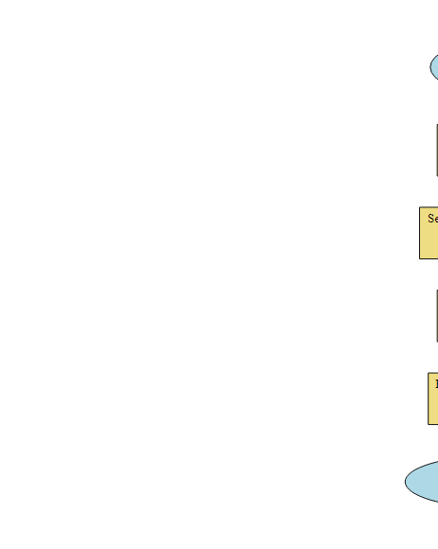 ##DAG
# Install dagitty if not already installed
if (!requireNamespace("dagitty", quietly = TRUE)) {
install.packages("dagitty")
}
# Load the dagitty package
library(dagitty)
## Warning: package 'dagitty' was built under R version 4.3.3
# Install ggdag if not already installed
if (!requireNamespace("ggdag", quietly = TRUE)) {
install.packages("ggdag")
}
# Load the library
library(ggdag)
## Warning: package 'ggdag' was built under R version 4.3.3
##
## Attaching package: 'ggdag'
## The following objects are masked from 'package:xtable':
##
## label, label<-
## The following object is masked from 'package:stats':
##
## filter

Descriptive Tables
table1::table1(~ Age + Gender + Loneliness + Number_of_friends + Smoking + Alcohol + Drug_use + Physical_Act +School_Environ + Parental_support+ Bullying | Suicide, data = Thai_R_Final)
 | No  (N=3828) | Yes  (N=719) | Overall  (N=4547)
Age
Under_11 | 3 (0.1%) | 1 (0.1%) | 4 (0.1%)
12_13 | 1072 (28.0%) | 244 (33.9%) | 1316 (28.9%)
14_15 | 1456 (38.0%) | 282 (39.2%) | 1738 (38.2%)
16_17 | 833 (21.8%) | 135 (18.8%) | 968 (21.3%)
Over_18 | 464 (12.1%) | 57 (7.9%) | 521 (11.5%)
Gender
Female | 2100 (54.9%) | 534 (74.3%) | 2634 (57.9%)
Male | 1728 (45.1%) | 185 (25.7%) | 1913 (42.1%)
Loneliness
Never | 1080 (28.2%) | 66 (9.2%) | 1146 (25.2%)
Rarely | 1112 (29.0%) | 98 (13.6%) | 1210 (26.6%)
Sometimes | 1160 (30.3%) | 212 (29.5%) | 1372 (30.2%)
Mosttimes | 319 (8.3%) | 215 (29.9%) | 534 (11.7%)
Always | 157 (4.1%) | 128 (17.8%) | 285 (6.3%)
Number_of_friends
0 | 196 (5.1%) | 61 (8.5%) | 257 (5.7%)
1 | 241 (6.3%) | 77 (10.7%) | 318 (7.0%)
2 | 332 (8.7%) | 77 (10.7%) | 409 (9.0%)
>3 | 3059 (79.9%) | 504 (70.1%) | 3563 (78.4%)
Smoking
No | 882 (23.0%) | 225 (31.3%) | 1107 (24.3%)
Yes | 2946 (77.0%) | 494 (68.7%) | 3440 (75.7%)
Alcohol
No | 1602 (41.8%) | 422 (58.7%) | 2024 (44.5%)
Yes | 2226 (58.2%) | 297 (41.3%) | 2523 (55.5%)
Drug_use
No | 284 (7.4%) | 76 (10.6%) | 360 (7.9%)
Yes | 3544 (92.6%) | 643 (89.4%) | 4187 (92.1%)
Physical_Act
No | 2704 (70.6%) | 495 (68.8%) | 3199 (70.4%)
Yes | 1124 (29.4%) | 224 (31.2%) | 1348 (29.6%)
School_Environ
Never | 323 (8.4%) | 85 (11.8%) | 408 (9.0%)
Rarely | 654 (17.1%) | 119 (16.6%) | 773 (17.0%)
Sometimes | 1262 (33.0%) | 223 (31.0%) | 1485 (32.7%)
Mosttimes | 1069 (27.9%) | 213 (29.6%) | 1282 (28.2%)
Always | 520 (13.6%) | 79 (11.0%) | 599 (13.2%)
Parental_support
Never | 993 (25.9%) | 287 (39.9%) | 1280 (28.2%)
Rarely | 703 (18.4%) | 144 (20.0%) | 847 (18.6%)
Sometimes | 985 (25.7%) | 162 (22.5%) | 1147 (25.2%)
Mosttimes | 596 (15.6%) | 62 (8.6%) | 658 (14.5%)
Always | 551 (14.4%) | 64 (8.9%) | 615 (13.5%)
Bullying
No | 3150 (82.3%) | 487 (67.7%) | 3637 (80.0%)
Yes | 678 (17.7%) | 232 (32.3%) | 910 (20.0%)

Visualize distribution Bar Graphs & Charts
library(ggplot2)
library(dplyr)
## distribution by Age
# Create a Age data frame
data <- data.frame(
Category = c("Under_11", "12_13", "14_15", "16_17", "Over_18"),
No = c(3, 1072, 1456, 833, 464),
Yes = c(1, 244, 282, 135, 57)
)
# Reshape data for plotting
data_long <- data %>%
gather(key = "Suicide_Ideation", value = "Count", -Category)
# Plot
ggplot(data_long, aes(x = Category, y = Count, fill = Suicide_Ideation)) +
geom_bar(stat = "identity", position = "dodge") +
labs(title = "Age Distribution by Suicide_Ideation", x = "Age Group", y = "Count") +
theme_minimal()
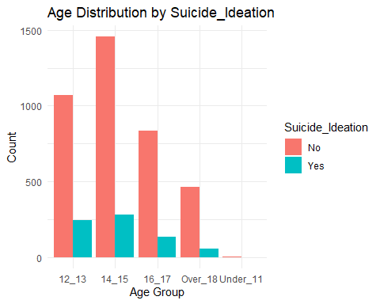
## Distribution by Gender
# Create the data for gender and 'Yes' outcome (from your table example)
gender_data <- data.frame(
Gender = c("Female", "Male"),
Yes = c(534, 185),
Total = c(2634, 1913)
)
# Calculate the percentage of "Yes" for each gender
gender_data$Percentage <- gender_data$Yes / gender_data$Total * 100
# Plot the pie chart
ggplot(gender_data, aes(x = "", y = Percentage, fill = Gender)) +
geom_bar(stat = "identity", width = 1) +
coord_polar(theta = "y") +
geom_text(aes(label = paste0(round(Percentage, 1), "%")), position = position_stack(vjust = 0.5)) +
labs(title = "Gender Distribution for 'Yes' Outcome") +
theme_void() +
scale_fill_manual(values = c("maroon", "darkgreen"))
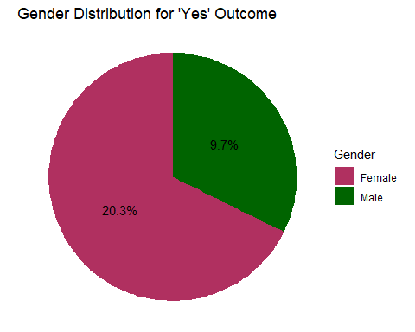
# Loneliness data example
loneliness_data <- data.frame(
Loneliness = c("Never", "Rarely", "Sometimes", "Mosttimes", "Always"),
No = c(1080, 1112, 1160, 319, 157),
Yes = c(66, 98, 212, 215, 128)
)
# Reshape data for plotting
loneliness_data_long <- loneliness_data %>%
gather(key = "Outcome", value = "Count", -Loneliness)
# Set the factor levels for the Loneliness variable in the desired order
loneliness_data_long$Loneliness <- factor(loneliness_data_long$Loneliness,
levels = c("Never", "Rarely", "Sometimes", "Mosttimes", "Always"))
# Plot
ggplot(loneliness_data_long, aes(x = Loneliness, y = Count, fill = Outcome)) +
geom_bar(stat = "identity", position = "dodge") +
labs(title = "Loneliness Distribution by Outcome", x = "Loneliness Level", y = "Count") +
theme_minimal()
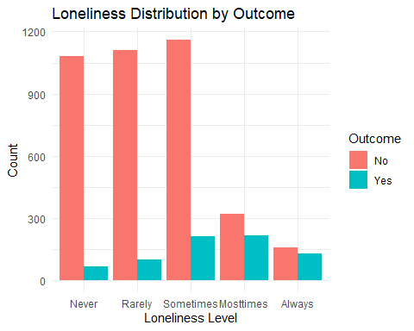
# Reshape data for plotting, focusing on the 'Yes' outcome
loneliness_data_long <- loneliness_data %>%
gather(key = "Outcome", value = "Count", -Loneliness) %>%
filter(Outcome == "Yes") # Filter to include only 'Yes' outcome
# Set the factor levels for the Loneliness variable in the desired order
loneliness_data_long$Loneliness <- factor(loneliness_data_long$Loneliness,
levels = c("Never", "Rarely", "Sometimes", "Mosttimes", "Always"))
# Plot_2
ggplot(loneliness_data_long, aes(x = Loneliness, y = Count, fill = Outcome)) +
geom_bar(stat = "identity", position = "dodge") +
labs(title = "Loneliness Distribution with 'Yes' Outcome", x = "Loneliness Level", y = "Count") +
theme_minimal()
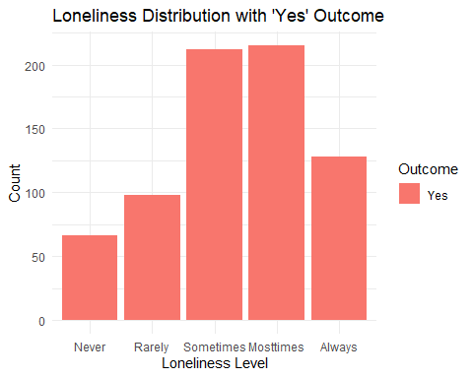
##Model
# Recode 'Yes' and 'No' to 1 and 0
Thai_R_Final $suicide <- ifelse(Thai_R_Final$Suicide == "Yes", 1, 0)
#Perform a general linear model
model_1 <- glm (Suicide ~ Loneliness + Age + Gender + Number_of_friends + Smoking + Alcohol + Drug_use + Physical_Act,
family = binomial(link = "logit"), data = Thai_R_Final)
summary(model_1)
##
## Call:
## glm(formula = Suicide ~ Loneliness + Age + Gender + Number_of_friends +
## Smoking + Alcohol + Drug_use + Physical_Act, family = binomial(link = "logit"),
## data = Thai_R_Final)
##
## Coefficients:
## Estimate Std. Error z value Pr(>|z|)
## (Intercept) -0.87394 1.22445 -0.714 0.47539
## LonelinessRarely 0.29206 0.16729 1.746 0.08084 .
## LonelinessSometimes 0.90845 0.15022 6.048 1.47e-09 ***
## LonelinessMosttimes 2.22824 0.15851 14.057 < 2e-16 ***
## LonelinessAlways 2.35212 0.18120 12.981 < 2e-16 ***
## Age12_13 -0.34323 1.19928 -0.286 0.77472
## Age14_15 -0.73395 1.19867 -0.612 0.54033
## Age16_17 -0.89659 1.20072 -0.747 0.45524
## AgeOver_18 -1.25354 1.20592 -1.039 0.29858
## GenderMale -0.83298 0.10366 -8.036 9.31e-16 ***
## Number_of_friends1 0.24555 0.21883 1.122 0.26182
## Number_of_friends2 -0.02632 0.21523 -0.122 0.90267
## Number_of_friends>3 -0.15382 0.17259 -0.891 0.37282
## SmokingYes -0.37381 0.11628 -3.215 0.00131 **
## AlcoholYes -0.60627 0.09661 -6.275 3.49e-10 ***
## Drug_useYes -0.14464 0.17118 -0.845 0.39812
## Physical_ActYes 0.01710 0.09682 0.177 0.85984
## ---
## Signif. codes: 0 '***' 0.001 '**' 0.01 '*' 0.05 '.' 0.1 ' ' 1
##
## (Dispersion parameter for binomial family taken to be 1)
##
## Null deviance: 3970.0 on 4546 degrees of freedom
## Residual deviance: 3313.3 on 4530 degrees of freedom
## AIC: 3347.3
##
## Number of Fisher Scoring iterations: 5
#confidence intervals
broom::tidy(model_1, exponentiate = TRUE, conf.int = TRUE)
## # A tibble: 17 × 7
## term estimate std.error statistic p.value conf.low conf.high
## <chr> <dbl> <dbl> <dbl> <dbl> <dbl> <dbl>
## 1 (Intercept) 0.417 1.22 -0.714 4.75e- 1 0.0191 3.79
## 2 LonelinessRarely 1.34 0.167 1.75 8.08e- 2 0.967 1.87
## 3 LonelinessSometimes 2.48 0.150 6.05 1.47e- 9 1.86 3.35
## 4 LonelinessMosttimes 9.28 0.159 14.1 6.97e-45 6.84 12.7
## 5 LonelinessAlways 10.5 0.181 13.0 1.57e-38 7.39 15.1
## 6 Age12_13 0.709 1.20 -0.286 7.75e- 1 0.0822 15.0
## 7 Age14_15 0.480 1.20 -0.612 5.40e- 1 0.0556 10.2
## 8 Age16_17 0.408 1.20 -0.747 4.55e- 1 0.0471 8.66
## 9 AgeOver_18 0.285 1.21 -1.04 2.99e- 1 0.0326 6.10
## 10 GenderMale 0.435 0.104 -8.04 9.31e-16 0.354 0.532
## 11 Number_of_friends1 1.28 0.219 1.12 2.62e- 1 0.833 1.97
## 12 Number_of_friends2 0.974 0.215 -0.122 9.03e- 1 0.639 1.49
## 13 Number_of_friends>3 0.857 0.173 -0.891 3.73e- 1 0.615 1.21
## 14 SmokingYes 0.688 0.116 -3.21 1.31e- 3 0.548 0.865
## 15 AlcoholYes 0.545 0.0966 -6.28 3.49e-10 0.451 0.659
## 16 Drug_useYes 0.865 0.171 -0.845 3.98e- 1 0.621 1.21
## 17 Physical_ActYes 1.02 0.0968 0.177 8.60e- 1 0.840 1.23
Check for Multicolinearity
car::vif(model_1)
## GVIF Df GVIF^(1/(2*Df))
## Loneliness 1.056266 4 1.006866
## Age 1.083856 4 1.010116
## Gender 1.128084 1 1.062113
## Number_of_friends 1.038548 3 1.006324
## Smoking 1.388724 1 1.178441
## Alcohol 1.167320 1 1.080426
## Drug_use 1.253450 1 1.119576
## Physical_Act 1.008347 1 1.004165

Introduce DataThaiInitial Data132 variables5,661 ObservationsFinal Cleaned DatasetThai_R_FinalSelect Relevant Variables:12 Variables5,661 ObservationsRename Variables:12 Variables5,661 ObservationsRemove Missing Data:12 Variables4,547 Observations

